

A PROJECT REPORT ON

**SCHOOL MANAGEMENT SYSTEM**

CSA0937 / Programming in Java and Analysis

**Submitted by:**

P.Tejasree 192110440

**SUPERVISOR**

                                                                   Dr.M. Buvanesvari

**SAVEETHA SCHOOL OF ENGINEERING,**

**SIMATS CHENNAI- 602105**

**MARCH-202**

 Date:                     Project Supervisor:                   Head of the Department:

**TABLE OF CONTENTS**

|  |  |  |
| --- | --- | --- |
| **S.NO** | **CONTENT** | **PAGE NO.** |
| 1. | OBJECTIVE | **3** |
| 2. | INTRODUCTION | **4** |
| 3. | CODE AND OUTPUT | **5** |
| 4 | LITERATURE SURVEY | **6** |
| 5 | CONCLUSION | **7** |
| 6. | FUTURE ENHANCEMENT | **8** |
| 7 | RESULT | **8** |

**OBJECTIVE:**

The goal of a school management system is to improve and expedite the operational, academic, and administrative procedures in educational establishments. Its main goal is to increase productivity through the digitization and automation of processes like resource management, schedule scheduling, grade recording, attendance tracking, and student enrolment. It promotes a collaborative learning environment by giving stakeholders—students, instructors, administrators, and parents—better communication through the provision of a centralised platform. Furthermore, by providing extensive analytics and reporting features, it facilitates data-driven decision-making and gives administrators the ability to pinpoint problem areas and carry out focused interventions. In the end, a well-thought-out school management system acts as a stimulant for superior academic performance, efficient organisational functioning, and general student achievement.

**INTRODUCTION:**

Efficient student registration and class administration procedures are made possible by a complete school management system, which also guarantees precise tracking of attendance and academic records.The class management feature of the system enables administrators to place students in particular classes according to their grade level, course prerequisites, and availability after they have enrolled.

By offering user-friendly interfaces for class selection and enrollment, the system expedites this procedure and guarantees that students are enrolled in courses that will best support their academic progress and aspirations.The system has strong attendance monitoring features in addition to class management to keep an eye on student participation and attendance. Teachers can use digital interfaces to record student attendance in real-time through the system's attendance module, doing away with the requirement for paper attendance forms and lowering the possibility of mistakes or inconsistencies. After that, administrators have access to attendance data and can create reports to spot trends, patterns, and areas where student engagement and attendance need to be improved.

In general, the school management system's class management and student registration capabilities give administrators strong tools to improve academic planning, expedite administrative procedures, and support student achievement. The system helps to create a more effective and efficient learning environment by centralising student data and automating repetitive processes, freeing up educators to concentrate on providing each student with excellent learning and assistance.

One of the most important facets of educational administration is class management, which includes planning, arranging, and coordinating the classes in a school or other educational setting. By guaranteeing that resources, students, and teachers are distributed effectively to maximise instructional time and encourage student success, it forms the basis for effective teaching and learning.Features like instructor assignment, resource allocation, enrollment management, and class scheduling are typical examples of class management functionality. In order to ensure that courses are set up in a way that maximises learning opportunities and minimises conflicts, administrators can develop and adjust class schedules based on variables like instructor availability, student preferences, and facility limits.

**CODE AND OUTPUT:**

import java.util.ArrayList;

import java.util.List;

import java.util.Scanner;

class Student {

private String name;

private int rollNo;

public Student(String name, int rollNo) {

this.name = name;

this.rollNo = rollNo;

}

public String getName() {

return name;

}

public int getRollNo() {

return rollNo;

}

}

class School {

private List<Student> students;

public School() {

students = new ArrayList<>();

}

public void admitStudent(Student student) {

students.add(student);

}

public Student findStudentByRollNo(int rollNo) {

for (Student student : students) {

if (student.getRollNo() == rollNo) {

return student;

}

}

return null; // Return null if student not found

}

public void displayAllStudents() {

System.out.println("List of all students:");

for (Student student : students) {

System.out.println("Name: " + student.getName() + ", Roll No: " + student.getRollNo());

}

}

}

public class SchoolManagementSystem {

public static void main(String[] args) {

Scanner scanner = new Scanner(System.in);

School school = new School();

while (true) {

System.out.println("\n1. Admit Student");

System.out.println("2. Search Student by Roll No");

System.out.println("3. Display All Students");

System.out.println("4. Exit");

System.out.print("Enter your choice: ");

int choice = scanner.nextInt();

switch (choice) {

case 1:

System.out.print("Enter student name: ");

String name = scanner.next();

System.out.print("Enter student roll number: ");

int rollNo = scanner.nextInt();

school.admitStudent(new Student(name, rollNo));

System.out.println("Student admitted successfully!");

break;

case 2:

System.out.print("Enter roll number to search: ");

int searchRollNo = scanner.nextInt();

Student foundStudent = school.findStudentByRollNo(searchRollNo);

if (foundStudent != null) {

System.out.println("Student found:");

System.out.println("Name: " + foundStudent.getName() + ", Roll No: " + foundStudent.getRollNo());

} else {

System.out.println("Student not found!");

}

break;

case 3:

school.displayAllStudents();

break;

case 4:

System.out.println("Exiting program...");

System.exit(0);

default:

System.out.println("Invalid choice! Please enter a valid option.");

}

}

}

}

**OUTPUT :**

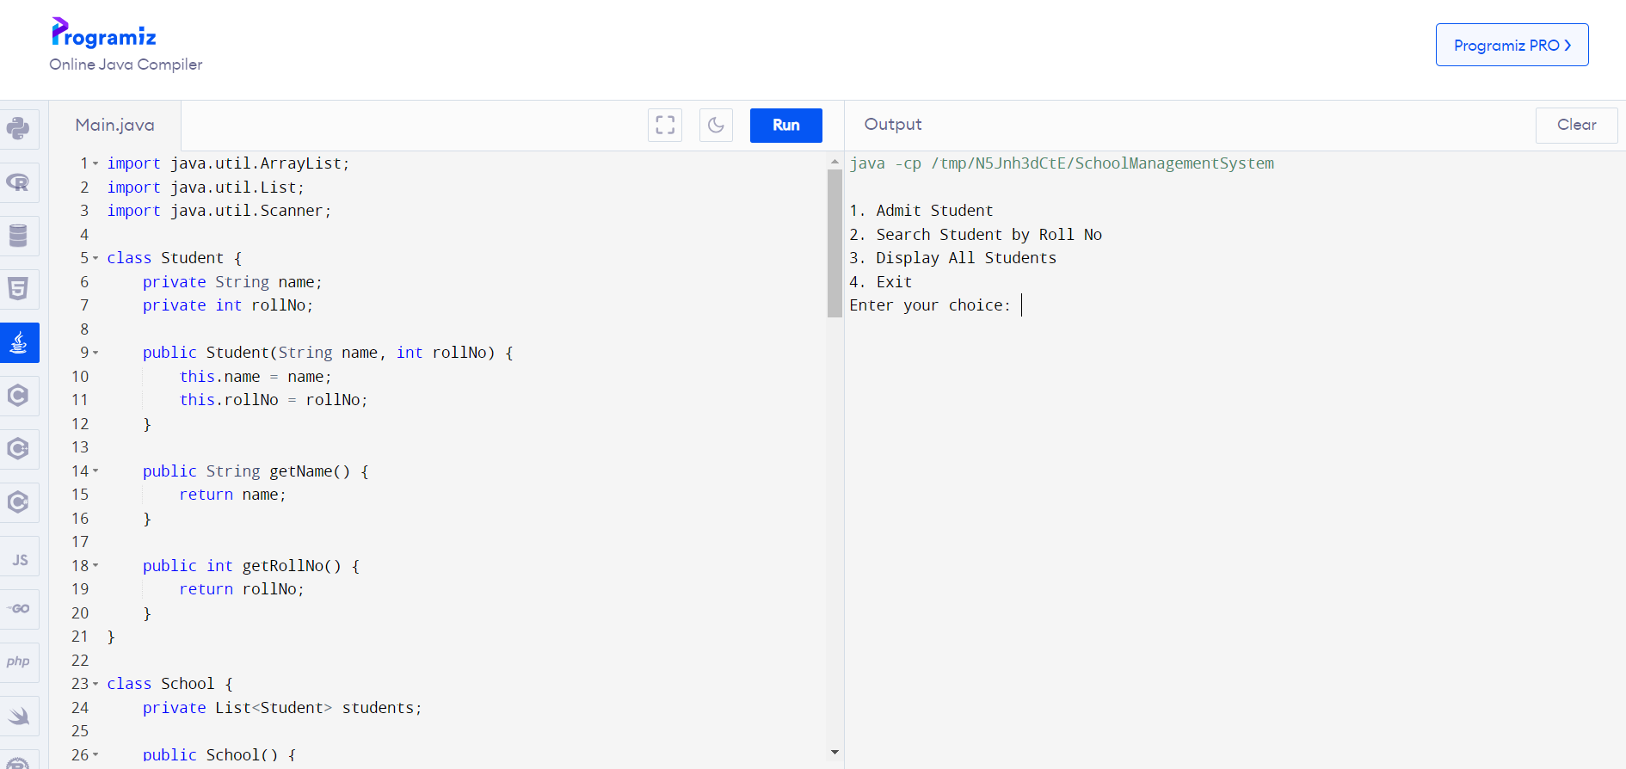

**LITERATURE SURVEY:**

1. "Academic journals And papers Design and implementation of school management system" by Adebesin, F. and Ogunlade, O.

This paper proposes a system that uses Student management system to automate attendance management. It discusses the implementation details and evaluates the system's performance.

1. "A Review on School Management System and Its Prospects in Bangladesh" by Md. Mahabub Alam and Md. Mahabubul Alam

This paper presents an RFID-based attendance management system. It explores the use of RFID technology to track students' attendance and discusses the advantages and challenges of this approach.

1. "An Analysis of the School Management Systems for School Development" by Olaniyi S. O.

Access to academic databases or libraries, you might want to search using the author's name or a similar title to see if the paper is available. Alternatively, if you have more information about the paper or its content.

1. "Information Systems for School Management: The Fusing of Computing and Collaboration Technologies" by Anthony Owen

This paper introduces a smartphone-based attendance system that utilizes QR code technology. It discusses the design and implementation of the system and evaluates its effectiveness in managing attendance.

1. "School Management Systems: Review and Implications for Educational Managers" by Hikmat Ullah Khan and Bashir Ahmad

This paper provides an overview of school management systems, their features, and their implications for educational managers. It discusses the role of technology in improving school administration and highlights the importance of selecting the right system to meet the needs of educational institutions.

1. "School Management Information Systems in Developing Countries" by Anthonia Adenike Adeniji

This paper explores the challenges and benefits of implementing school management information systems (MIS) in developing countries. It discusses the impact of MIS on improving data management, decision-making, and overall school performance.

1. "School Management Systems: A Review" by Fatimah Wahi Al-Hazmi and Ahmed Mohammed Esmail

This review article provides an in-depth analysis of various school management systems available in the market. It discusses the features, functionalities, and usability of these systems, along with their potential benefits for educational institutions.

Overall, a school management system enhances efficiency, transparency, and communication within educational institutions, leading to improved administrative processes and better educational outcomes for students.

**CONCLUSION:**

School Management System (SMS) revolutionizes the way educational institutions manage their administrative tasks, communicate with stakeholders, and analyze data. By automating processes such as student enrollment, attendance tracking, and grade management, an SMS saves time and reduces manual errors for teachers and staff. Furthermore, its communication features enhance collaboration between teachers, students, parents, and administrators, fostering greater parental involvement and transparency. The data management capabilities of an SMS enable administrators to make informed decisions based on comprehensive insights into student performance and institutional metrics. Overall, a School Management System streamlines operations, improves communication, and enhances accountability, ultimately contributing to the efficient and effective functioning of educational institutions. School Management System (SMS) serves as a pivotal tool in modernizing and optimizing educational institutions' administrative processes. By integrating various functionalities such as student enrollment, attendance tracking, grade management, resource allocation, and communication tools into a single platform, an SMS streamlines operations and enhances efficiency.

**FUTURE ENHANCEMENT:**

1. **Integration with Learning Management Systems (LMS):** Integration with LMS platforms would allow for seamless management of online courses, assignments, quizzes, and learning materials. This would facilitate blended learning environments and provide students with access to educational resources beyond the traditional classroom setting.
2. **Data Analytics and Predictive Insights:** Implementing advanced analytics capabilities would enable administrators to analyze student performance data, identify trends, and generate predictive insights to support targeted interventions and personalized learning plans. This could help in improving academic outcomes and student retention rates.
3. **Mobile Application:** Developing a mobile application for the SMS would provide users (students, parents, teachers, and administrators) with convenient access to key functionalities such as attendance tracking, grade management, communication tools, and notifications. Mobile apps can enhance accessibility and engagement, especially for users who are constantly on the go.
4. **Biometric Attendance System:** Implementing a biometric attendance system would improve accuracy and efficiency in tracking student attendance. Biometric authentication methods such as fingerprint or facial recognition could be integrated into the SMS to automate attendance recording and eliminate manual processes.
5. **Virtual Classroom:** Incorporating virtual classroom capabilities would enable real-time video conferencing, screen sharing, and interactive collaboration tools within the SMS. This would facilitate remote learning opportunities, virtual lectures, and online tutoring sessions, thereby extending the reach of the educational institution beyond physical boundaries.
6. **Parental Engagement Tools:** Enhancing parental engagement features within the SMS would involve providing parents with access to their child's academic progress, attendance records, and school announcements in real-time. Additionally, interactive features such as parent-teacher conference scheduling, appointment reminders, and feedback mechanisms could be incorporated to promote active involvement in their child's education.
7. **Blockchain for Academic Credentials:** Implementing blockchain technology to securely store and verify academic credentials (e.g., diplomas, certificates, transcripts) would enhance the authenticity and integrity of student records. Blockchain-based credentialing systems could simplify the verification process for employers, educational institutions, and other stakeholders.
8. **Artificial Intelligence (AI) Chatbots:** Integrating AI-powered chatbots into the SMS could provide users with instant assistance and support for common inquiries, such as course enrollment, schedule management, and FAQs. AI chatbots can handle routine tasks, answer questions, and provide personalized recommendations, thereby enhancing user satisfaction and efficiency.
9. **Accessibility Features:** Ensuring that the SMS is accessible to users with disabilities by incorporating features such as screen readers, keyboard navigation shortcuts, and color contrast adjustments. Accessibility enhancements would promote inclusivity and ensure equitable access to educational resources for all students, parents, and staff members.
10. **Scalability and Customization:** Designing the SMS architecture to be scalable and customizable to accommodate the evolving needs of educational institutions of varying sizes and requirements. Modular architecture and flexible configuration options would enable seamless integration of new features, customization of workflows, and scalability to support growing user bases.

**RESULT:**

The result of a capstone project on a school management system would typically be a functional, well-documented software solution that meets the specified requirements and demonstrates the student's skills and knowledge in software development, project management, and problem-solving. The term "Capstone System" can refer to various things depending on the context. It could be a specific software platform, a project management methodology, or an educational program, among other things.